**ASSIGNMENT**



**NAME:** Koushik Sripathi Panditaradhyula

**ROLL NO:** 123CS0021

**SUBJECT:** CS1010 (Basic Computer Programming for Problem Solving)

**Assignment**

1. Write a program using nested if-else to find whether an entered number is negative, positive, or zero.

ANSWER:

Code for the program

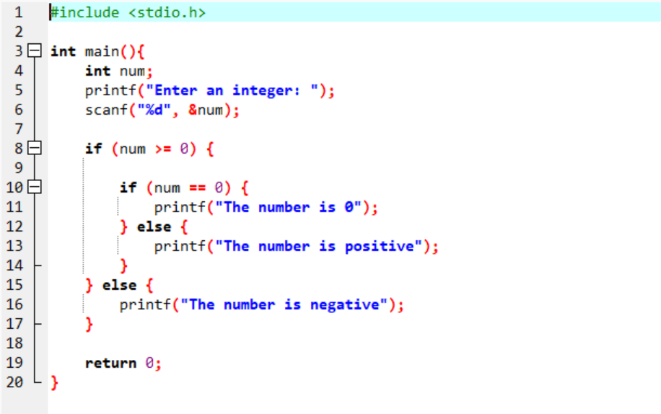

Outputs for the program:

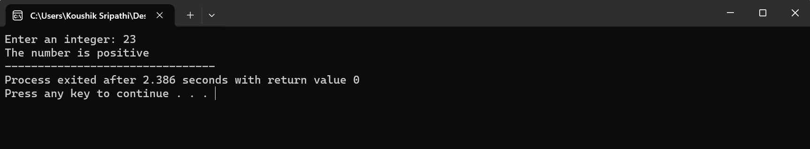

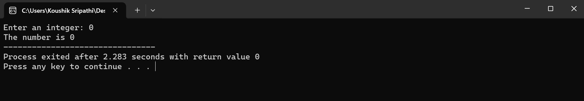

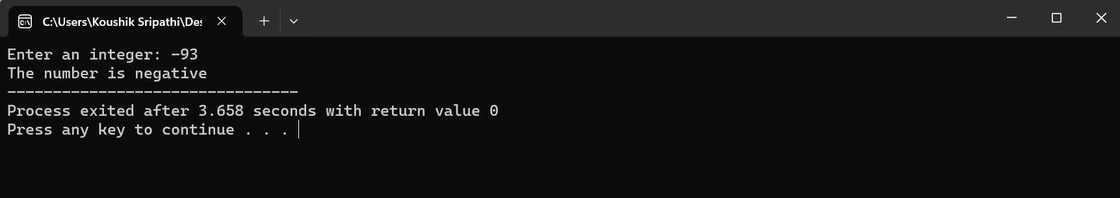

1. Write a program to find the largest number among the three numbers using: (a) if and logical and (&&) operator; (b) Nested If-else statement

ANSWER: (a)

Code for the program: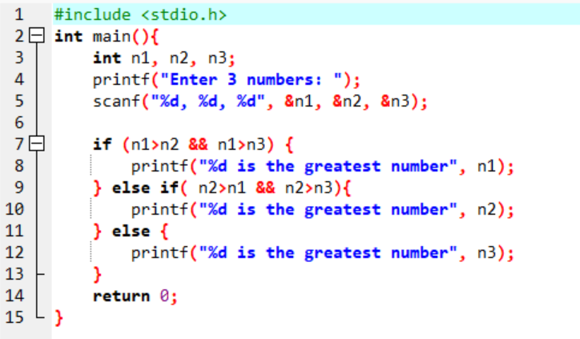

Outputs for the program:

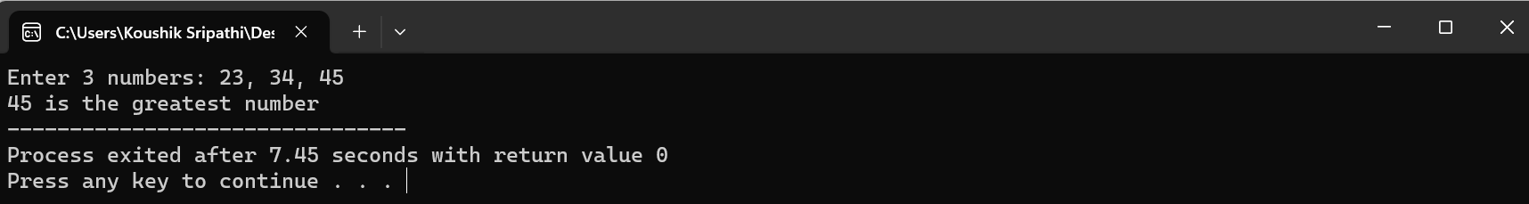

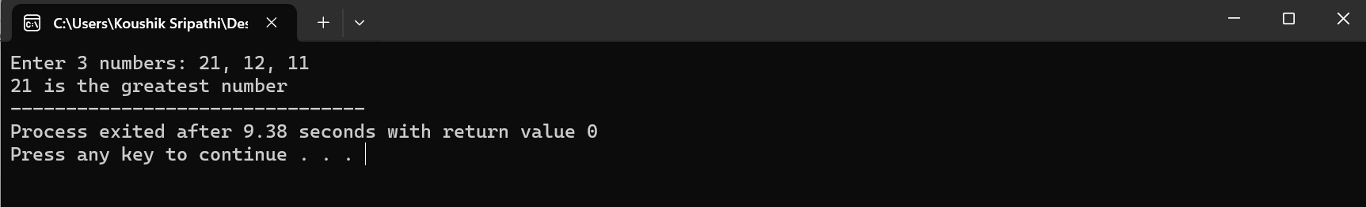

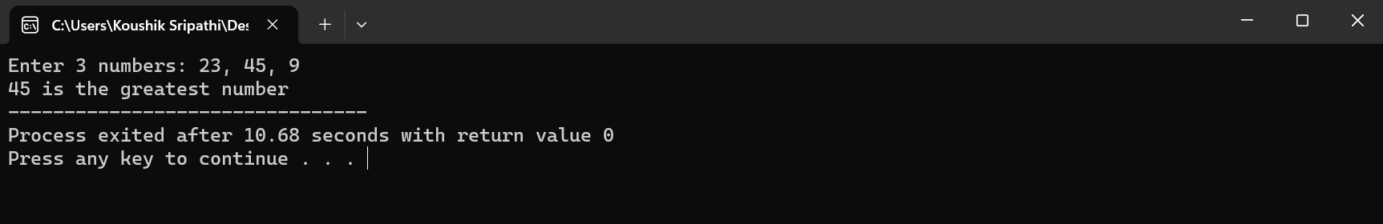

ANSWER: (b)

Code for the program:

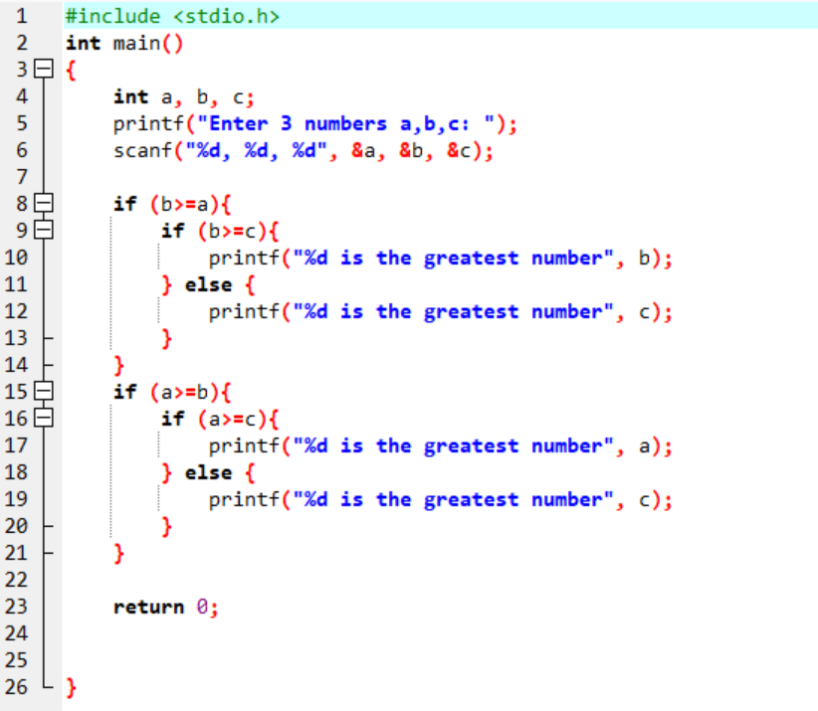

Outputs for the program:

